Stu 1.ID: Name 1:
Stu 2.ID: Name 2:

Reference Solution
Lab 6: Determine motor position and PID Control
Task 1 – Determine motor position from Hall-effect Rotary Encoder:
The actual counts per revolution is __193__
Screenshot of encoderCount and position when motor move forward (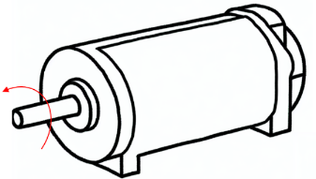):

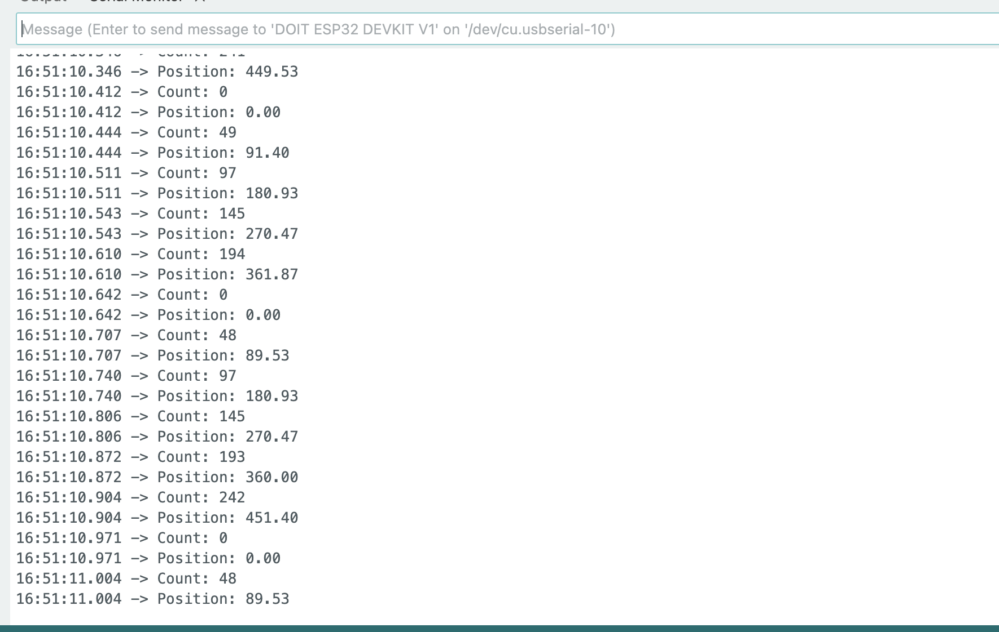

Screenshot of encoderCount and position when motor move backward (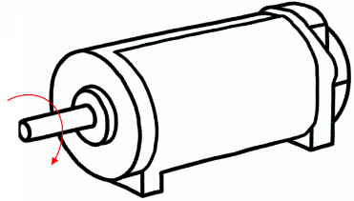):

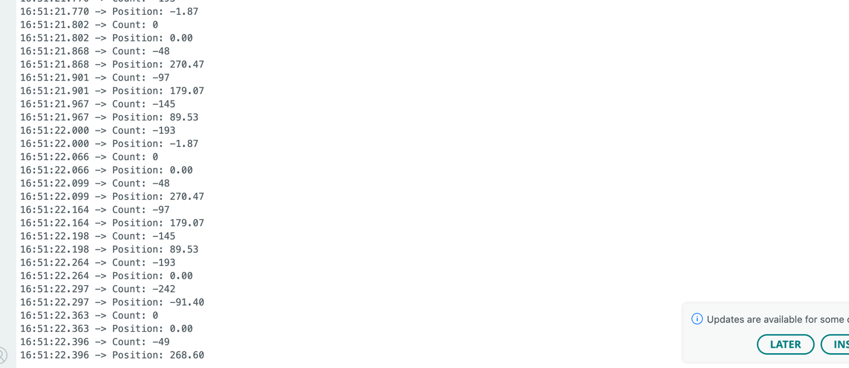

Task 2 – P controller
Kp=___0.48____

Task 3 – PI controller
Ki=____0.0003_

Task 4 – PID controller
Kd=____0.05_

Please Submit the answer sheet to Canvas/Assignments/Lab6_Answer Sheet

